Key Performance Indicators Recopilación de Spiro Strategy spirostrategy.com

KPI Library http://kpilibrary.com/
(Sólo se puede acceder a este menú con un registro previo gratuito. El más completo.)
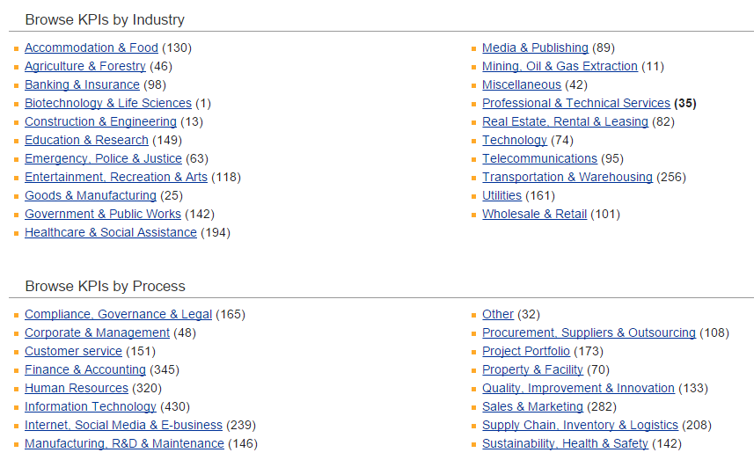

KPI examples[edit]

Marketing & Sales[edit]
Some examples are:
- New customers acquisition.
- Demographic analysis of individuals (potential customers) applying to become customers, and the levels of approval, rejections, and pending numbers
- Status of existing customers
- Customer attrition
- Turnover (i.e., revenue) generated by segments of the customer population
- Outstanding balances held by segments of customers and terms of payment
- Collection of bad debts within customer relationships
- Profitability of customers by demographic segments and segmentation of customers by profitability
Many of these customer KPIs are developed and managed with customer relationship management software.
Faster availability of data is a competitive issue for most organizations. For example, businesses which have higher operational/credit risk (involving for example credit cards or wealth management) may want weekly or even daily availability of KPI analysis, facilitated by appropriate IT systems and tools.

Manufacturing[edit]
Overall equipment effectiveness, is a set of broadly accepted non-financial metrics which reflect manufacturing success.
- OEE = Availability x Performance x Quality
- Availability = Run Time / Total Time
By Definition: Percentage of the actual amount of production time the machine is running to the production time the machine is available.
- Performance = Total Count / Target Counter
By Definition: Percentage of total parts produced on the machine to the production rate of machine.
- Quality = Good Count / Total Count
By Definition: Percentage of good parts out of the total parts produced on the machine.
- Cycle Time – Cycle time is the total time from the beginning to the end of your process, as defined by you and your customer. Cycle time includes process time, during which a unit is acted upon to bring it closer to an output, and delay time, during which a unit of work is spent waiting to take the next action.
- Cycle Time Ratio (CTR) – CTR = Standard Cycle Time / Real Cycle Time
- Utilization
- Rejection rate

IT Operations[edit]
- Availability / Uptime
- Mean time between failure
- Mean time to repair
- Unplanned unavailability

IT Project Execution[edit]
- Earned Value
- Estimate to Complete
- Labor Spent / Month
- Dollars Spent / Month
- Planned Dollars / Month
- Planned Labor / Month
- Average Time to Delivery
- Tasks / Staff
- Project Overhead / ROI
- No. of New Customers
- Planned Delivery Date vs Actual Delivery Date
- Net Promoter Score

Supply chain management[edit]
Businesses can utilize KPIs to establish and monitor progress toward a variety of goals, including lean manufacturing objectives, minority business enterprise and diversity spending, environmental "green" initiatives, cost avoidance programs and low-cost country sourcing targets.
Any business, regardless of size, can better manage supplier performance with the help of KPIs robust capabilities, which include:
- Automated entry and approval functions
- On-demand, real-time scorecard measures
- Rework on procured inventory
- Single data repository to eliminate inefficiencies and maintain consistency
- Advanced workflow approval process to ensure consistent procedures
- Flexible data-input modes and real-time graphical performance displays
- Customized cost savings documentation
- Simplified setup procedures to eliminate dependence upon IT resources
Main SCM KPIs will detail the following processes:
- Sales forecasts
- Inventory
- Procurement and suppliers
- Warehousing
- Transportation
- Reverse logistics

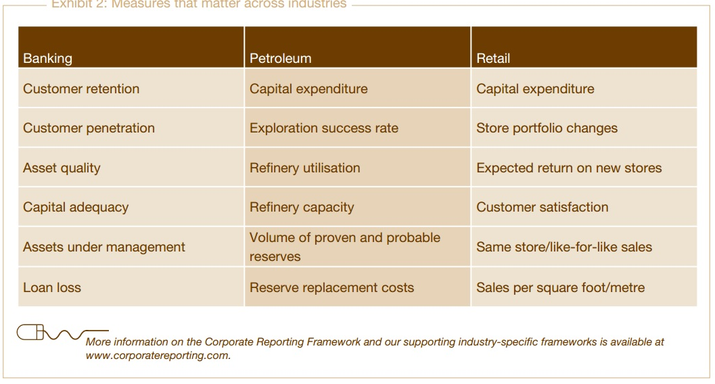

To measure financial performance:
1. Net Profit
2. Net Profit Margin
3. Gross Profit Margin
4. Operating Profit Margin
5. EBITDA
6. Revenue Growth Rate
7. Total Shareholder Return (TSR)
8. Economic Value Added (EVA)
9. Return on Investment (ROI)
10. Return on Capital Employed (ROCE)
11. Return on Assets (ROA)
12. Return on Equity (ROE)
13. Debt-to-Equity (D/E) Ratio
14. Cash Conversion Cycle (CCC)
15. Working Capital Ratio
16. Operating Expense Ratio (OER)
17. CAPEX to Sales Ratio
18. Price Earnings Ratio (P/E Ratio)

To understand your customers:
19. Net Promoter Score (NPS)
20. Customer Retention Rate
21. Customer Satisfaction Index
22. Customer Profitability Score
23. Customer Lifetime Value
24. Customer Turnover Rate
25. Customer Engagement
26. Customer Complaints

To gauge your market and marketing efforts:
27. Market Growth Rate
28. Market Share
29. Brand Equity
30. Cost per Lead
31. Conversion Rate
32. Search Engine Rankings (by keyword) and click-through rate
33. Page Views and Bounce Rate
34. Customer Online Engagement Level
35. Online Share of Voice (OSOV)
36. Social Networking Footprint
37. Klout Score

To measure your operational performance:
38. Six Sigma Level
39. Capacity Utilisation Rate (CUR)
40. Process Waste Level
41. Order Fulfilment Cycle Time
42. Delivery In Full, On Time (DIFOT) Rate
43. Inventory Shrinkage Rate (ISR)
44. Project Schedule Variance (PSV)
45. Project Cost Variance (PCV)
46. Earned Value (EV) Metric
47. Innovation Pipeline Strength (IPS)
48. Return on Innovation Investment (ROI2)
49. Time to Market
50. First Pass Yield (FPY)
51. Rework Level
52. Quality Index
53. Overall Equipment Effectiveness (OEE)
54. Process or Machine Downtime Level
55. First Contact Resolution (FCR)

To understand your employees and their performance:
56. Human Capital Value Added (HCVA)
57. Revenue Per Employee
58. Employee Satisfaction Index
59. Employee Engagement Level
60. Staff Advocacy Score
61. Employee Churn Rate
62. Average Employee Tenure
63. Absenteeism Bradford Factor
64. 360-Degree Feedback Score
65. Salary Competitiveness Ratio (SCR)
66. Time to Hire
67. Training Return on Investment

To measure your environmental and social sustainability performance:
68. Carbon Footprint
69. Water Footprint
70. Energy Consumption
71. Saving Levels Due to Conservation and Improvement Efforts
72. Supply Chain Miles
73. Waste Reduction Rate
74. Waste Recycling Rate
75. Product Recycling Rate

KPI – Key Performance Indicators
Key Performance Indicators are used in four main areas:
- Revenue improvement
- Cost reduction
- Process cycle-time improvement
- Increased customer satisfaction
The following are KPI examples from real-life scenarios. Using these KPIs will benefit in reducing overheads, errors, delays and costs.

Business Process – Key Performance Indicators
The following are KPI examples for gauging business process performance:
- Percentage of processes where completion falls within +/- 5% of the estimated completion
- Average process overdue time
- Percentage of overdue processes
- Average process age
- Percentage of processes where the actual number assigned resources is less than planned number of assigned resources
- Sum of costs of “killed” / stopped active processes
- Average time to complete task
- Sum of deviation of time (e.g. in days) against planned schedule of all active projects

Service Level Agreement (SLA) – Key Performance Indicators
The following are KPI examples of SLA performance:
- Percentage of service requests resolved within an agreed-upon/acceptable period of time
- Cost of service delivery as defined in Service Level Agreement (SLA) based on a set period such as month or quarter
- Percentage of outage (unavailability) due to implementation of planned changes, relative to the service hours
- Average time (e.g. in hours) between the occurrence of an incident and its resolution
- Downtime – the percentage of the time service is available
- Availability – the total service time = the mean time between failure (MTBF) and the mean time to repair (MTTR)
- Number of outstanding actions against last SLA review
- The deviation of the planned budget (cost) is the difference in costs between the planned baseline against the actual budget of the Service Level Agreement (SLA)
- Percentage of correspondence replied to on time
- Percentage of incoming service requests of customers have to be completely answered within x amount of time
- Number of complaints received within the measurement period
- Percentage of customer issues that were solved by the first phone call
- Number of operator activities per call – maximum possible, minimum possible, and average. (E.g. take call, log call, attempt dispatch, retry dispatch, escalate dispatch, reassign dispatch, etc.)
- The number of answered phone call per hour
- Total Calling Time per Day or week.
- Average queue time of incoming phone calls
- Cost per minute of handle time
- Number of un-responded emails
- Average after call work time (work done after call has been concluded)
- Costs of operating a call centre / service desk, usually for a specific period such as month or quarter
- Average number of calls / service requests per employee of call center / service desk within measurement period
- Number of complaints received within the measurement period

Service Quality – Key Performance Indicators
The following are KPI examples for gauging Service Quality performance:
- Cycle time from request to delivery
- Call length – the time to answer a call
- Volume of calls handled – per call centre staff
- Number of escalations how many bad
- Number of reminders – how many at risk
- Number of alerts – overall summary
- Customer ratings of service – customer satisfaction
- Number of customer complaints – problems
- Number of late tasks – late

Efficiency – Key Performance Indicators
The following are KPI examples indicating Efficiency performance:
- Cycle time from request to delivery
- Average cycle time from request to delivery
- Call length
- Volume of tasks per staff
- Number of staff involved
- Number of reminders
- Number of alerts
- Customer ratings of service
- Number of customer complaints
- Number of process errors
- Number of human errors
- Time allocated for administration, management, training

Compliance – Key Performance Indicators
The following are KPI examples for Compliance performance:
- Average time lag between identification of external compliance issues and resolution
- Frequency (in days) of compliance reviews

Budget – Key Performance Indicators
- Sum of deviation in money of planned budget of projects

Index used in Key Performance Indicators
The following indices are used in KPI as indicators:
Tolerating: The user notices performance lagging within responses greater than T, but continues the process.
Frustrated: Performance with a response time greater than F seconds is unacceptable, and users may abandon the process.
Satisfied: The user is fully productive. This represents the time value (T seconds) below which users are not impeded by application response time.

MAIN CHARACTERISTICS The following list shows the main characteristics associated with KPIs, they should:
Conform to a company’s strategy – this is an extremely important point, as mentioned above. If there is no clear link between a KPI and a company’s business objectives, then a KPI is not a KPI. The indicator may well be an operational or secondary metric, but it is not a key performance indicator.
Be easy to understand – this may be a very obvious point but it tends to be forgotten. It is easy to imagine the different problems in productivity which a poor understanding of the indicators might lead to. If the KPIs are used to communicate, then everyone involved needs to agree on what they are used for and what they mean.
Allow for action – a measurement which cannot be influenced, even indirectly, is not of great importance. It is extremely important that people are aware of how the evolution of KPIs can be monitored and influenced.
Be contextual – it should also be easy to adapt KPIs to the creation of different targets which are to be reached and to the creation of lower thresholds, both of which are part of the continuous improvement of interactive marketing. At the beginning of the year we recommend that a company clearly define its growth or objectives depending on the indicators that have been used. KPIs will also be used to make it easier to determine how marketing activities will contribute to objectives being reached throughout the year.

